**Project Report of Police Information System**

Six weeks Industrial Training Report at

**Solitaire Infosys, Patiala.**

**BACHELOR OF TECHNOLOGY**

**IN**

**COMPUTER SCIENCE & ENGINEERING**

**Submitted By:**

**Harrasleen Singh**

**Roll NO.=11701071**



**DEPARTMENT OF COMPUTER SCIENCE & ENGINEERING**

**PUNJABI UNIVERSITY PATIALA**

**Table of Content**

|  |  |  |
| --- | --- | --- |
| SR. No. | DESCRIPTION | PAGE NO. |
| 1. | Acknowledgement | 3 |
| 2. | Certificate | 4 |
| 3. | Abstract | 5 |
| 4. | List of Figures | 6 |
| 5. | Training Schedule | 7 |
| 6. | Company Information | 8 |
| 7. | Platform description | 10 |
| 8. | Project Introduction | 14 |
| 9. | ER Diagrams | 16 |
| 10. | Data Flow Diagram | 16 |
| 11. | Form Description/Snapshots | 17 |
| 12. | Report Description/Snapshots | 19 |
| 13. | Future Scope | 21 |
| 14. | Conclusion | 21 |
| 15. | Bibliography | 22 |

1. **ACKNOWLEDGEMENT**

Apart from the efforts of me, the success of my project depends largely on the encouragement and guidelines of many others. It was a wonderful experience to work on this project and I would like to express my gratitude towards anyone who helped us at any stage. I take this opportunity to express my gratitude to the people who have been instrumental in the successful completion of this project. I would like to show my greatest appreciation to my trainer and also project in-charge. I can’t say thank you enough for the tremendous support and help. I feel motivated and encouraged every time I attend her class. She provide us very well knowledge, guidance and inspiration throughout the training. Without her encouragement, guidance and efforts this project work would not have materialized.

I would like to express a deep sense of gratitude and thank Mr. Surjit Singh , Director/CEO of Company, without whose permission, wise counsel and able guidance, it would have not been possible to pursue my training in this manner.

Finally, I express my indebtedness to all who have directly or indirectly contributed to the successful completion of my industrial training.

1. **Certificate**

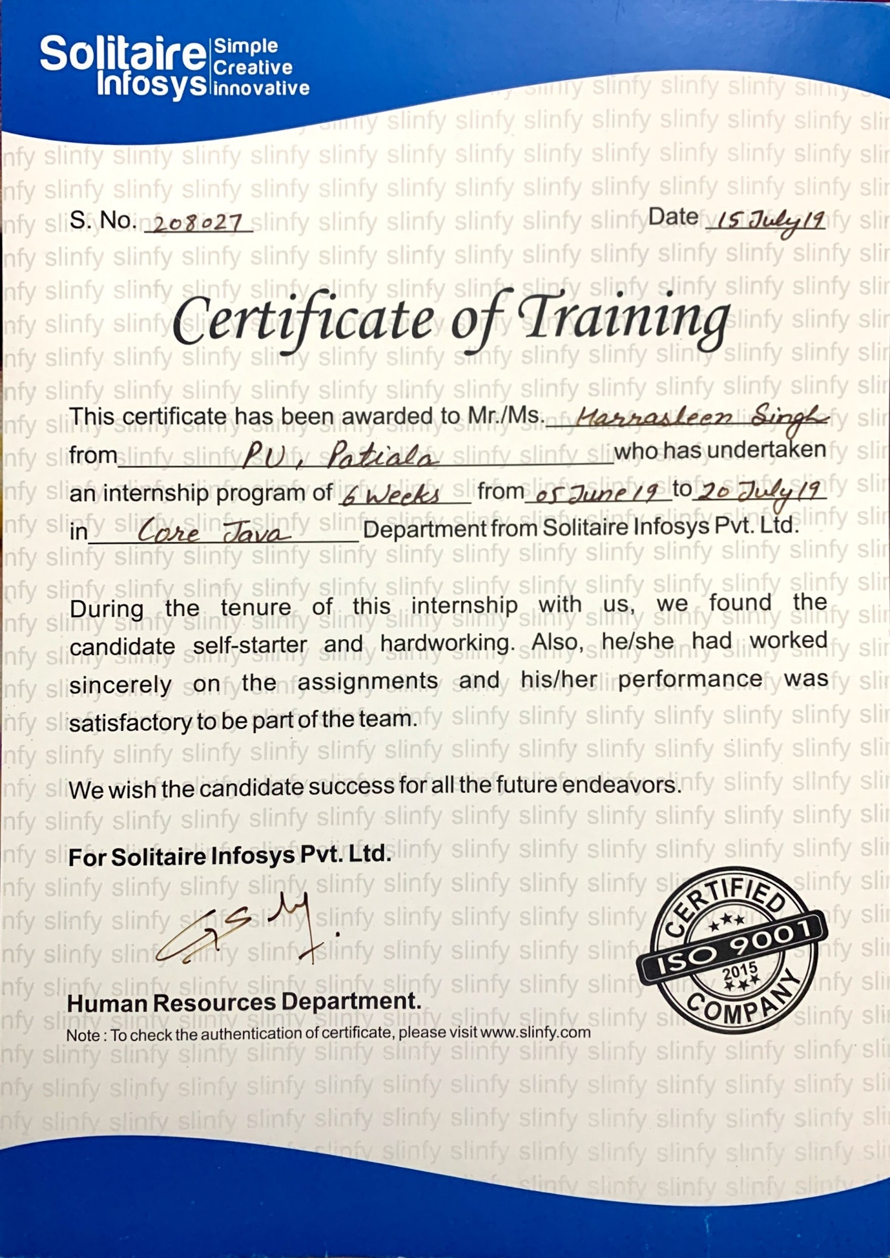

**3. ABSTRACT**

Police Information System is basically a java application which is used to help the Policemen to keep a record of things which require lots of paper work. It includes filing an FIR (First Information Record), reporting about a missing person, Registration of Senior Citizens and also allows the police to keep the records of the criminals. This system is a lot beneficial to police as it will help to maintain the records easily and efficiently.

The main basic modules which form the base of Police Information System :-

* Login Module.
* Record Management Module.
* Criminal Module.
* Missing Module.
* FIR Module.
* Search Module for all

Police Information System requires the Police to login before any updation in the System. It is secure enough to meet the needs of the Police.

Police Information System uses JDK for its frontend and MySQL as its database at backend.

Policemen can enter the records whether it is FIR, Senior Citizen, Criminal or even the missing person. Police Information System also facilitates policemen to search the records of FIR, Senior Citizen, Criminal or even the missing person whenever they need them.

**4. List of Figures**

|  |  |  |
| --- | --- | --- |
| **S. No.** | **Title** | **Page No.** |
| 1. | Java | 10 |
| 2. | NetBeans | 11 |
| 3. | MySQL | 11 |
| 4. | JDBC | 12 |
| 5. | ER Diagram | 16 |
| 6. | DFD | 16 |
| 7. | Forms Description | 17 |
| 8. | Reports Description | 19 |

**5. Training Schedule**

|  |  |  |  |
| --- | --- | --- | --- |
| **S. no.** | **Date** | **Day** | **Topic** |
| 1. | 5/6/17 | Mon | Basics and Core Components |
| 2. | 6/6/17 | Tues | Features and History |
| 3. | 7/6/17 | Wed | JVM Architecture and Byte-Code |
| 4. | 8/6/17 | Thurs | A little bit of Code and Class files |
| 5. | 9/6/17 | Fri | Data Types Operators |
| 6. | 12/6/17 | Mon | Control Constricts |
| 7. | 14/6/17 | Wed | Array |
| 8. | 16/6/17 | Fri | String Handling- Using Strings, String Buffer Classes |
| 9. | 19/6/17 | Mon | OOPS and OOPS in java |
| 10. | 20/6/17 | Tues | Classes and Objects |
| 11. | 21/6/17 | Wed | Methods and Constructors |
| 12. | 23/6/17 | Fri | Packages and Interfaces |
| 13. | 26/6/17 | Mon | Access Specifies |
| 14. | 27/6/17 | Tues | Exception Handling |
| 15. | 29/6/17 | Thurs | Threads and Multithreading |
| 16. | 30/6/17 | Fri | Wrapper Classes and Inner Classes |
| 17. | 3/7/17 | Mon | Applet Programming |
| 18. | 3/7/17 | Mon | Java API (The Java Class Libraries) |
| 19. | 4/7/17 | Tues | ‘Java.lang’-Java’s language Fundamentals |
| 20. | 5/7/17 | Wed | ‘Java.io’-Java’s I/O Mechanism |
| 21. | 6/7/17 | Thurs | ‘Java.util’-Utilities & Collections Framework |
| 22. | 10/7/17 | Mon | ‘Java.awt.event’-GUI Applications using Java |
| 23. | 12/7/17 | Wed | ‘Javax.swing’-Java’s Extended GUI Programming |

**6. Company Information**

**6.1 An Overview:-**

SOLITAIRE INFOSYS is a leading Software and Web Application Development Company, based in Mohali (Chandigarh) that provides high quality comprehensive services to enterprises across a wide range of platforms and technologies. Our major areas of expertise are in providing quality, cost effective software or web development.

**6.2 Focus of the Company:-**

The Company focuses on understanding the diverse and mission-critical needs of each of our clients. To understand is to be able to deliver. The competence and experience of our company gives us a competitive edge by making sure we provide the best services and products to our clients. Our high-quality standards enable us to deliver reliable and error-free software applications, despite their complexity.

The Company provides Web design/Web development, B2B & B2C E-commerce solutions, SEO & Web Promotions strategies implementation consulting services to both domestic as well as international client’s at the most affordable rates.

**6.3 History of the Company:-**

Solitaire Infosys Inc. was a dream came into existence over three years ago with a strong aspiration of becoming a best IT service provider around the globe. Presently, Solitaire Infosys is already leading the race with its competitors. Being nurtured by a team of experienced and sensitive people. We try to bond emotionally with our clients and love to go an extra mile to satisfy their needs, which is the reason that we hold the edge in the league.

At Solitaire Infosys Inc. we provide the experience, expertise and capabilities that enable organizations to accelerate their service processes, deliver more service value and realize breakthrough results in the markets they serve. Now our clients not only appreciate our comprehensive range of services, our innovative, streamlined and cost effective solutions, but more importantly, they appreciate our high level of excellent customer service which is unparalleled in the industry.

**7. Platform Description**

**7.1 Java**

Java is a programming language developed by Sun Microsystems. It implements a strong security model, which prevents compiled Java programs from illicitly accessing resources on the system where they execute or on the network popular World Wide Web and other browsers as well as some World Wide Web servers and other system implement Java interpreters These are used to display interactive user interfaces, and to script behaviour on these systems While implementation problems have opened security vulnerabilities in some java interpreters (Java virtual Machines or JVM'S),the design of this language makes it at least theoretically possible to execute program with reasonable assurances about its Security, and in particular its ability to cause harm.

An editor of the java platform is the name for a bundle of related program from sun which allow for and running program written in the java programming language. The platform is not specific to any one processor or operating system, but rather an execution engine (called a virtual machine and a complier with a set of libraries that are implemented for various hardware and operating system so that java program can run identically on all of them.

**Characteristics of Java**

* Java is platform independent.
* Java is robust and secure.
* Java is object oriented.
* Multi-Threaded.
* Java is dynamic.
* High performance.
* Java is portable.

The java Platform consists of several program, each of which provides a distinct portion of its overall capabilities. For example, the java complier, which converts java source code into java byte code (an intermediate language for the Java Virtual Machine (JVM)) is provided as part of the Java Development Kit (JDK).The Java Runtime Environment (JRM), complementing the JVM with a just-in-time (JIT) complier, coverts intermediates byte code into native machine code on the fly. Also supplied are extensive libraries, pre-compiled in which are several other components, some available only in certain editions.

**7.2 Netbeans**

NETBEANS is an integrated development environment (IDE) for developing primarily with JAVA, but also with other languages, in particular PHP, C/C++, and HTML5.It is also an application platform framework for java desktop applications and others.

The Netbeans IDE is written in java and can run on window-shops, Linux, Solaris and other platforms supporting a compatible JVM.

The Netbeans platform allows applications to be developed from a set of modular software components called modules. Applications based on the Netbeans platform can be extended y third party developers.

The net beans team actively support the product and seek feature suggestions from the wider community. Every release is preceded by a time for community testing and feedback.

The basic versions used are:

NetbeansIDE 6.9, released in june2010, added support for OSGi, Spring Framework 3.0, Java EE dependency injection(JSR 299), Zend Framework for PHP and easier code navigation(such as “Is Overridden/implemented” annotations), formatting, hints, and refactoring across several languages.

Netbeans IDE 7.0 was released in April 2011.On August1, 2011 the Netbeans Team released Netbeans IDE7.0.1 which has full support for the official release of the JAVA SE 7 platform.

**7.3 MySQL**

MySQL is a fast, easy-to-use RDBMS being used for many small and big businesses. MySQL is developed, marketed, and supported by MySQL AB, which is a Swedish company. MySQL is becoming so popular because of many good reasons:

* MySQL is released under an open-source license. So you have nothing to pay to use it.
* MySQL is a very powerful program in its own right. It handles a large subset of the functionality of the most expensive and powerful database packages.
* MySQL uses a standard form of the well-known SQL data language.
* MySQL works on many operating systems and with many languages including PHP, PERL, C, C++, JAVA, etc.
* MySQL works very quickly and works well even with large data sets.
* MySQL is very friendly to PHP, the most appreciated language for web development.
* MySQL supports large databases, up to 50 million rows or more in a table. The default file size limit for a table is 4GB, but you can increase this (if your operating system can handle it) to a theoretical limit of 8 million terabytes (TB).
* MySQL is customizable. The open-source GPL license allows programmers to modify the MySQL software to fit their own specific environments.

**JDBC**

JDBC stands for **J**ava **D**ata**b**ase **C**onnectivity, which is a standard Java API for database-independent connectivity between the Java programming language and a wide range of databases.

The JDBC library includes APIs for each of the tasks mentioned below that are commonly associated with database usage.

* Making a connection to a database.
* Creating SQL or MySQL statements.
* Executing SQL or MySQL queries in the database.
* Viewing & Modifying the resulting records.

## JDBC Architecture:

The JDBC API supports both two-tier and three-tier processing models for database access but in general, JDBC Architecture consists of two layers −

* JDBC API**:** This provides the application-to-JDBC Manager connection.
* JDBC Driver API**:** This supports the JDBC Manager-to-Driver Connection.

The JDBC API uses a driver manager and database-specific drivers to provide transparent connectivity to heterogeneous databases.

The JDBC driver manager ensures that the correct driver is used to access each data source. The driver manager is capable of supporting multiple concurrent drivers connected to multiple heterogeneous databases.

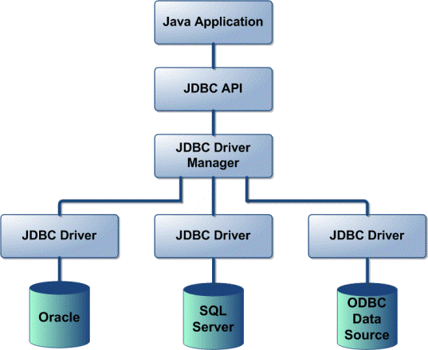

**JDBC Components:**

The JDBC API provides the following interfaces and classes:

* **Driver Manager:** This class manages a list of database drivers. Matches connection requests from the java application with the proper database driver using communication sub protocol. The first driver that recognizes a certain sub-protocol under JDBC will be used to establish a database Connection.
* **Driver:** This interface handles the communications with the database server. You will interact directly with Driver objects very rarely. Instead, you use Driver Manager Objects, which manages objects of this type. It also abstracts the details associated with working with Driver objects.
* **Connection:** This interface with all methods for contacting a database. The connection object represents communication context, i.e., all communication with database is through connection object only.
* **Statement:** You use objects created from this interface to submit the SQL statements to the database. Some derived interfaces accept parameters in addition to executing stored procedures.
* **ResultSet:** These objects hold data retrieved from a database after you execute an SQL query using Statement objects. It acts as an iterator to allow you to move through its data.

**8. Project Introduction**

Police Information System is basically a java application which is used to help the Policemen to keep a record of things which require lots of paper work. It includes filing an FIR (First Information Record), reporting about a missing person, it also allows the police to keep the records of the criminals. This system is a lot beneficial to police as it will help to maintain the records easily and efficiently.

The main basic modules which form the base of Police Information System are:-

* Login Module.
* Record Management Module.
* Criminal Registration Module.
* Report Missing Module.
* FIR Module.
* Search Module for all.

**8.1 Operations:**

**8.1.1 Login Module:** Policemen are required to login with the specific username and password to surf Police Station Record Management System. If the policemen forgets his/her password then the hint provided on the login page gives them a hint which is very related to the username and password itself so that they can easily remember the password.

**8.1.2 Record Management Module:** In this particular module the policemen is given access to filing FIR(First Information Record), reporting about a missing person, Registration of Senior Citizens, to keep the records of the criminals and also search these particular records with a single click.

**8.1.4 Criminal Registration Module:** In this module, the policemen can register the criminal record and which includes the details of them like Age, No. of crimes committed, Type of crimes committed, Address, Bounty on him/her, Gender, etc. It facilitates the Policemen to keep the records of criminals so that they can contact them or track them down easily as soon as possible.

**8.1.5 Report Missing Module:** In this module, the Policemen can keep the records of the missing person and search the person with the data given like Age, Gender, Religion, Height, Weight, Contact of the person who reported the missing person, etc.

**8.1.6 FIR (First Information Record) Module:** In this module, the Policemen can file down a FIR. Here they can specify the type of mis-happening, Description, and also few details of the person who is filing the FIR like Gender, Age, Contact, Address, etc.

**8.1.7 Search Modules:** These modules provide a facility to search the records of Senior Citizens, Criminals, FIRs or even the missing person whenever they need them. These modules are made separately for each module above mentioned like Senior Citizens, FIR, Criminals and Missing Reports.

**8.2 Functions carried out in police station record management system:**

* + Secure Login.
  + Back option available in all the modules.
  + Report Missing person.
  + Filing the FIR.
  + Registration of criminals.
  + Search option available to search any record of any module.

**8.3 Features of the project:**

* Secure Login with Hint available.
* You can choose the task you want to perform with one click.
* Report the missing the persons and also search these records.
* File the FIR and also search these records.
* Register the Criminal and also search the records of the criminal.

**9. ER diagram:**

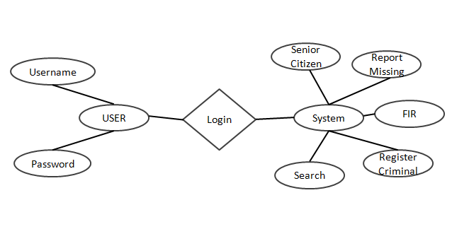

**10. Data Flow Diagram:**

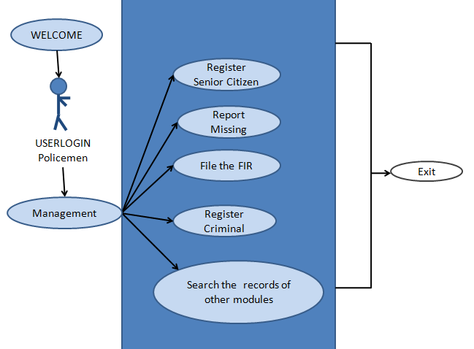

**11. Form Description:-**

**11.1 Home Page:-**

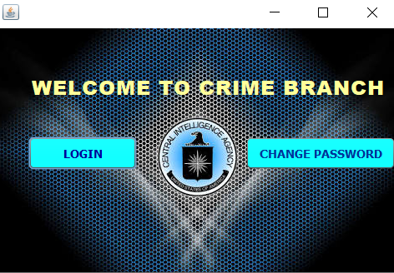

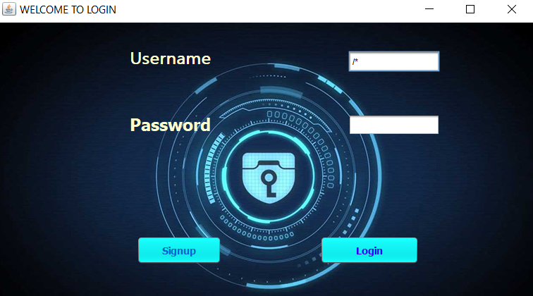**11.2 Log In page:-**

**11.3 FIR Registration:-**

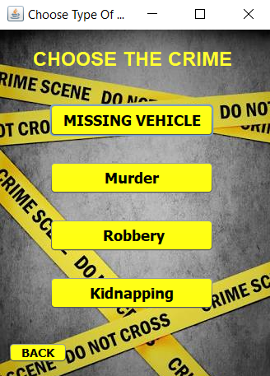

**11.4 View FIR:-**

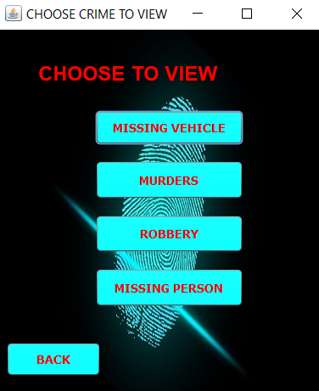

**12. Reports Description:-**

**12.1 FIR Record View:-**

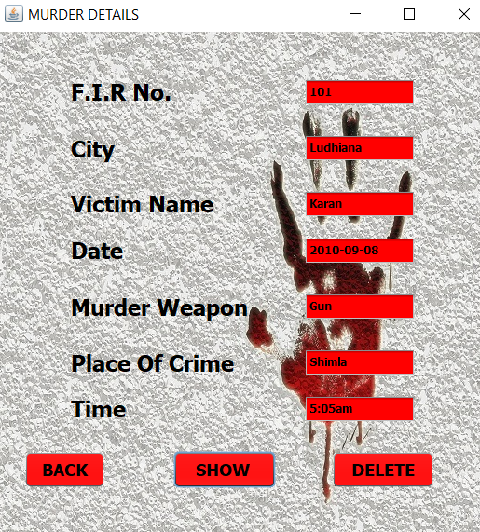

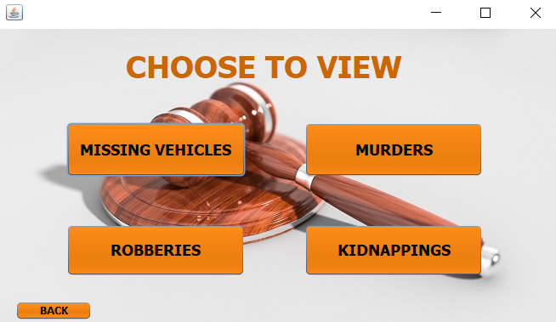**12.2 FIR Record:-**

**12.3 Criminal Record register:-**

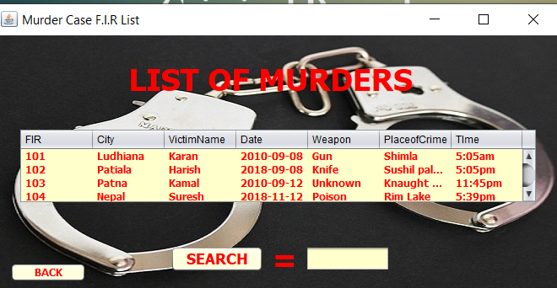

**13. Future Scope**

* In future we can use Image reorganization instead of using heterogeneous database more over High speed, accuracy and non-redundant data are the main advantages of the proposed system.
* Data entry errors can be minimized through validity checks. After the verification only the data are placed the permanent database.
* The software can be developed further to include a lot of modules because the proposed system is developed on the view of future.
* Data can be uploaded online so it could decrease the hardware cost.
* Databases can be connected with the other Police Stations so that the other Police Stations can also access the information.
* Efficient and well planned Tracking system can be established so that a Criminal can be caught as soon as possible.

**14. Conclusion**

In the concluding section, it can be said that the proposed system is efficient enough against the given requirements, it is quite time-efficient, convenient to use, user friendly, consistent and provides enough security.

The system has been developed for the given condition and is found working effectively. The developed system is flexible and changes whenever can be made easy. Using the facilities and functionalities of java, the software has been developed in a neat and simple manner, thereby reducing the operators work.

The speed and accuracy are maintained in proper way. The user friendly nature of this software developed in java framework is very easy to work with both for the higher management as well as other people with little knowledge of computer.

Working with NeatBeans and wamp Server the 1st time experience for me and i liked it very much. I had worked individually on C, C++, Visual Basic 6.0,J2SE before but this was totally a new experience.

Some of these technologies were new to me and I am greatly thankful to my sir for his excellent teaching which greatly helped us..

**15. Bibliography**

1. http://www.google.com
2. http://www.wikipedia.com
3. https://www.javatpoint.com/java-tutorial
4. https://www.tutorialspoint.com/java/
5. www.geeksforgeeks.org/java/
6. https://www.tutorialspoint.com/mysql/
7. ssJ2EE (book provided by Solitaire Infosys)